**ASSIGNMENT – 8**

**ON: GROUP FUNCTIONS AND AGGREGATING DATA**

**Determine the validity of the following three statements. Circle either True or False.**

**Q1. Group functions work across many rows to produce one result per group.**

Ans1.

True

**Q2. Group functions include nulls in calculations.**

Ans2.

False

We can use NVL to include null values.

**Q3. The WHERE clause restricts rows prior to inclusion in a group calculation.**

Ans3.

True

**Q4. Display the highest, lowest, sum, average salary of all employees. Label the columns Maximum, Minimum, Sum, Average, respectively. Round your results to the nearest whole number. Place your SQL statement in a text file named lab8_4.sql.**

|  |  |  |  |
| --- | --- | --- | --- |
| **Maximum** | **Minimum** | **Sum** | **Average** |
| **24000** | **2500** | **175500** | **8775** |

Ans4.

SELECT ROUND(MAX(SALARY),0) "Maximum",

ROUND(MIN(SALARY),0) "Minimum",

ROUND(SUM(SALARY),0) "Sum",

ROUND(AVG(SALARY),0) "Average"

FROM EMPLOYEES;

**Verification table –**

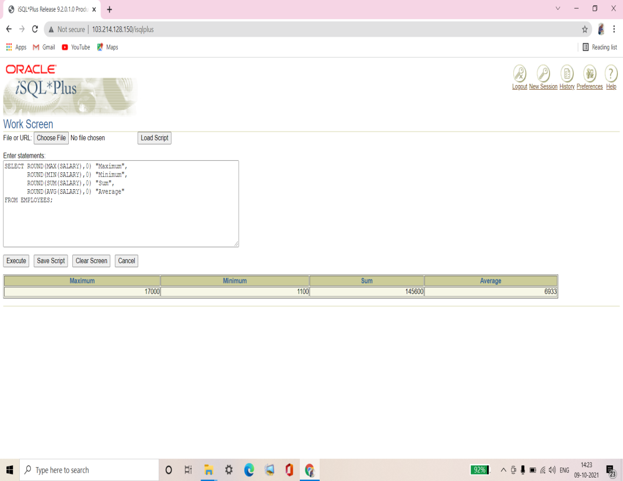

**Q5. Modify the query in lab8_4.sql to display the minimum, maximum, sum, and average salary for each job type. Resave lab8_4.sql to lab8_5.sql. Run the statement in a lab8_5.sql.**

|  |  |  |  |  |
| --- | --- | --- | --- | --- |
| **JOB_ID** | **Maximum** | **Minimum** | **Sum** | **Average** |
| **AC_ACCOUNT** | **8300** | **8300** | **8300** | **8300** |
| **AC_MGR** | **12000** | **12000** | **12000** | **12000** |
| **AD_ASST** | **4400** | **4400** | **4400** | **4400** |
| **AD_PRES** | **24000** | **24000** | **24000** | **24000** |
| **AD_VP** | **17000** | **17000** | **34000** | **17000** |
| **IT_PROG** | **9000** | **4200** | **19200** | **6400** |
| **MK_MAN** | **13000** | **13000** | **13000** | **13000** |
| **MK_REP** | **6000** | **6000** | **6000** | **6000** |
| **SA_MAN** | **10500** | **10500** | **10500** | **10500** |
| **SA_REP** | **11000** | **7000** | **26600** | **8867** |
| **ST_CLERK** | **3500** | **2500** | **11700** | **2925** |
| **ST_MAN** | **5800** | **5800** | **5800** | **5800** |

Ans5.

SELECT JOB_ID, ROUND(MAX(SALARY),0) "Maximum",

ROUND(MIN(SALARY),0) "Minimum",

ROUND(SUM(SALARY),0) "Sum",

ROUND(AVG(SALARY),0) "Average"

FROM EMPLOYEES

GROUP BY JOB_ID;

**Verification table –**

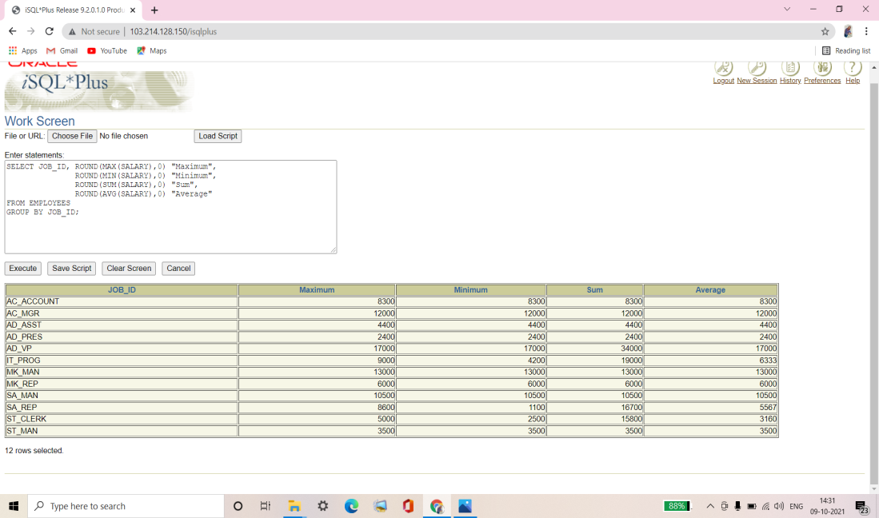

**Q6. Write a query to display the number of people with the same job.**

|  |  |
| --- | --- |
| **JOB_ID** | **COUNT(*)** |
| **AC_ACCOUNT** | **1** |
| **AC_MGR** | **1** |
| **AD_ASST** | **1** |
| **AD_PRES** | **1** |
| **AD_VP** | **2** |
| **IT_PROG** | **3** |
| **MK_MAN** | **1** |
| **MK_REP** | **1** |
| **SA_MAN** | **1** |
| **SA_REP** | **3** |
| **ST_CLERK** | **4** |
| **ST_MAN** | **1** |

**12 rows selected.**

Ans6.

SELECT JOB_ID, COUNT(*)

FROM EMPLOYEES

GROUP BY JOB_ID;

**Verification table –**

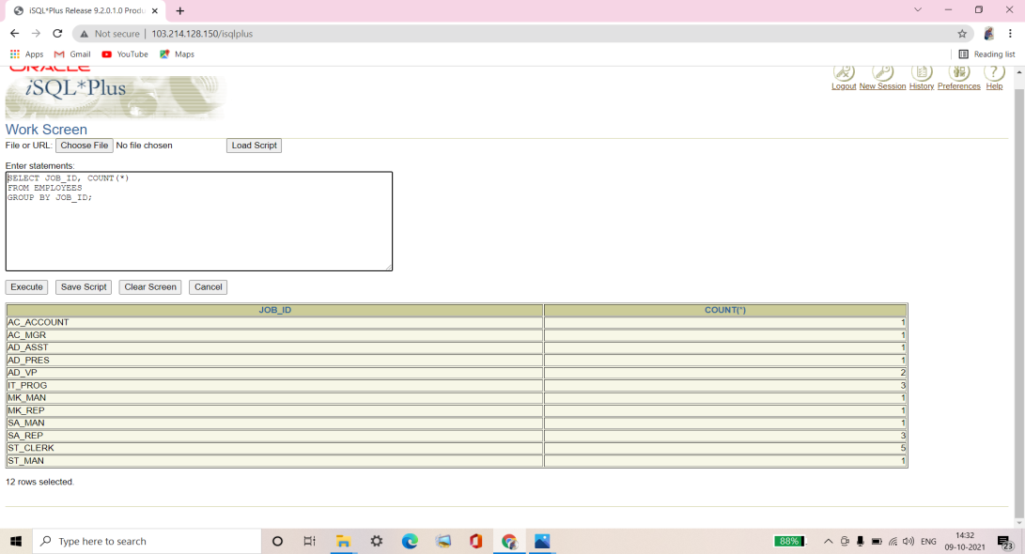

**Q7. Determine the number of managers without listing them. Label the column Number of Managers. Hint: Use the MANAGER_ID column to determine the number of managers.**

|  |
| --- |
| **Number of Managers** |
| **8** |

Ans7.

SELECT COUNT(DISTINCT MANAGER_ID) "Number of Managers"

FROM EMPLOYEES;

**Verification table –**

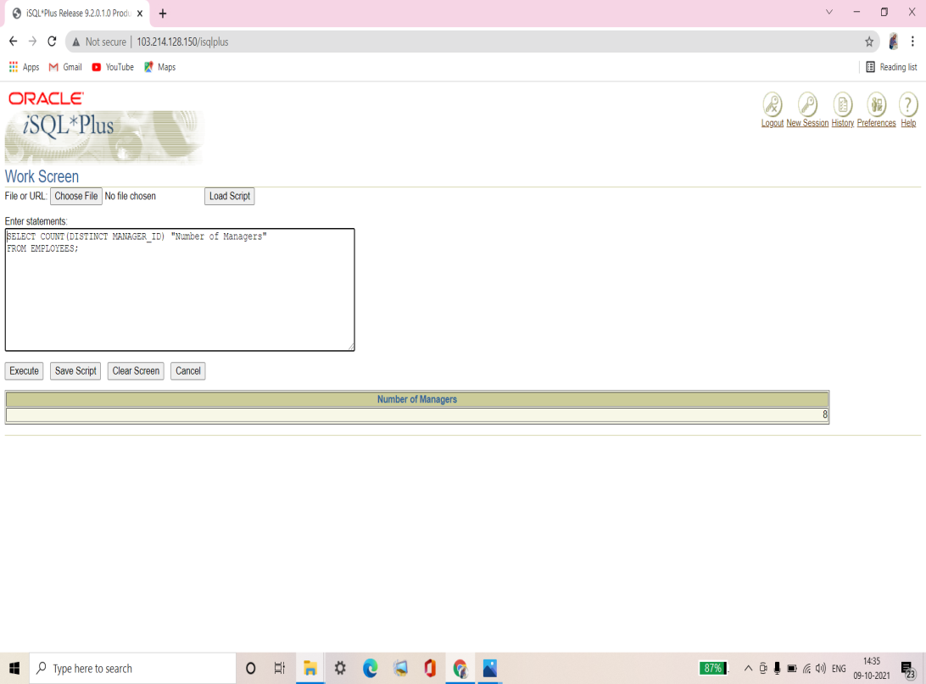

**Q8. Write a query that displays the difference between the highest and lowest salaries. Label the column DIFFERENCE.**

|  |
| --- |
| **DIFFERENCE** |
| **21500** |

Ans8.

SELECT MAX(SALARY)-MIN(SALARY) DIFFERENCE

FROM EMPLOYEES;

**Verification table –**

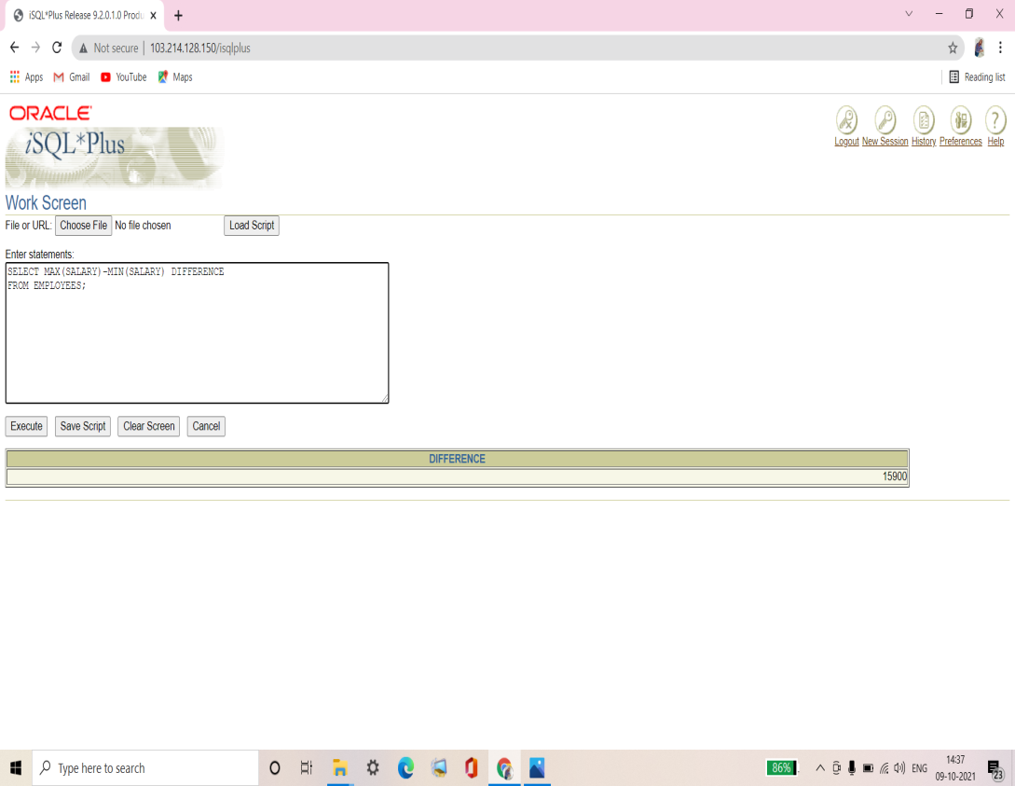

**Q9. Display the manager number and the salary of the lowest paid employee for that manager. Exclude anyone whose manager is not known. Exclude any groups where the minimum salary is less than $6,000. Sort the output in descending order of salary.**

|  |  |
| --- | --- |
| **MANAGER_ID** | **MIN(SALARY)** |
| **102** | **9000** |
| **205** | **8300** |
| **149** | **7000** |

Ans9.

SELECT MANAGER_ID, MIN(SALARY)

FROM EMPLOYEES

WHERE MANAGER_ID IS NOT NULL

GROUP BY MANAGER_ID

HAVING MIN(SALARY) >= 6000

ORDER BY MIN(SALARY) DESC;

**Verification table –**

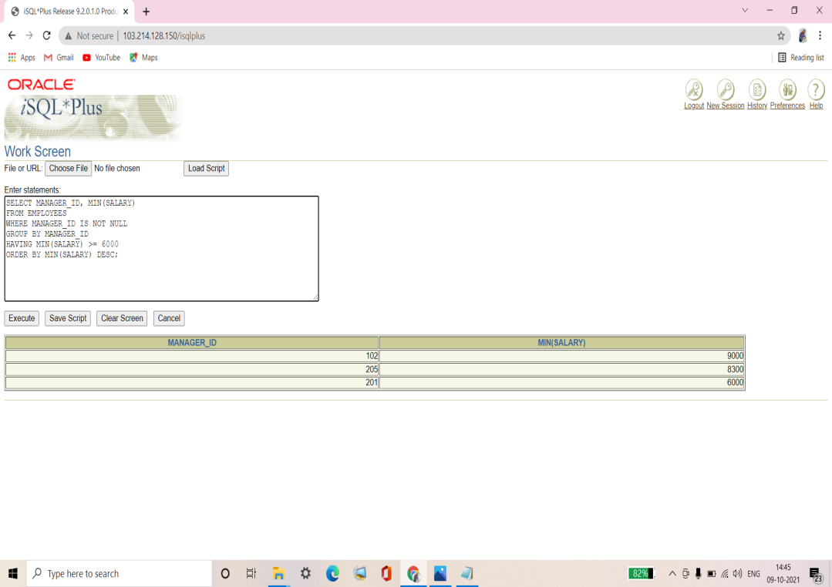

**Q10. Write a query to display each department’s name, location, number of employees, and the average salary for all employees in that department. Label the columns Name, Location, Number of People, and Salary, respectively. Round the average salary to two decimal places.**

|  |  |  |  |
| --- | --- | --- | --- |
| **Name** | **Location** | **Number of People** | **Salary** |
| **Accounting** | **1700** | **2** | **10150** |
| **Administration** | **1700** | **1** | **4400** |
| **Executive** | **1700** | **3** | **19333.33** |
| **IT** | **1400** | **3** | **6400** |
| **Marketing** | **1800** | **2** | **9500** |
| **Sales** | **2500** | **3** | **10033.33** |
| **Shipping** | **1500** | **5** | **3500** |

**7 rows selected.**

Ans10.

SELECT d.department_name "Name", d.location_id "Location",

COUNT(*) "Number of People",

ROUND(AVG(Salary),2) "Salary"

FROM employees e, departments d

WHERE e.department_id = d.department_id

GROUP BY d.department_name, d.location_id;

**Verification table –**

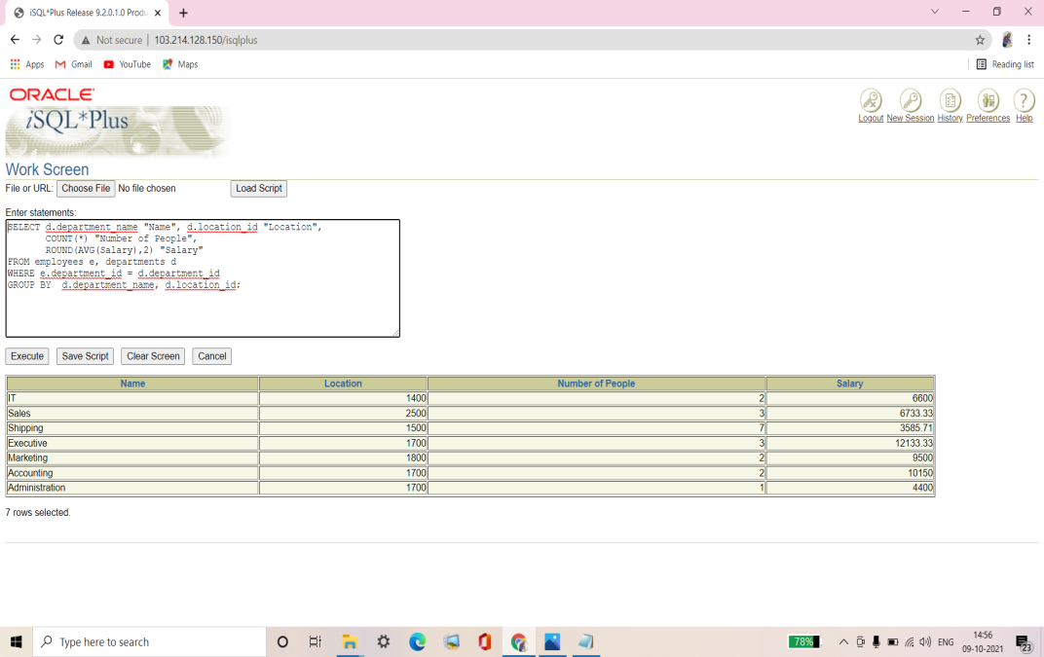

**Q11. Create a query that will display the total number of employees and, of that total, the number of employees hired in 1995, 1996, 1997, and 1998. Create appropriate column headings.**

|  |  |  |  |  |
| --- | --- | --- | --- | --- |
| **TOTAL** | **1995** | **1996** | **1997** | **1998** |
| **20** | **1** | **2** | **2** | **3** |

Ans11.

SELECT COUNT(*) TOTAL,

SUM(DECODE(TO_CHAR(HIRE_DATE, 'YYYY'),1995,1,0)) "1995",

SUM(DECODE(TO_CHAR(HIRE_DATE, 'YYYY'),1996,1,0)) "1996",

SUM(DECODE(TO_CHAR(HIRE_DATE, 'YYYY'),1997,1,0)) "1997",

SUM(DECODE(TO_CHAR(HIRE_DATE, 'YYYY'),1998,1,0)) "1998"

FROM EMPLOYEES;

**Verification table –**

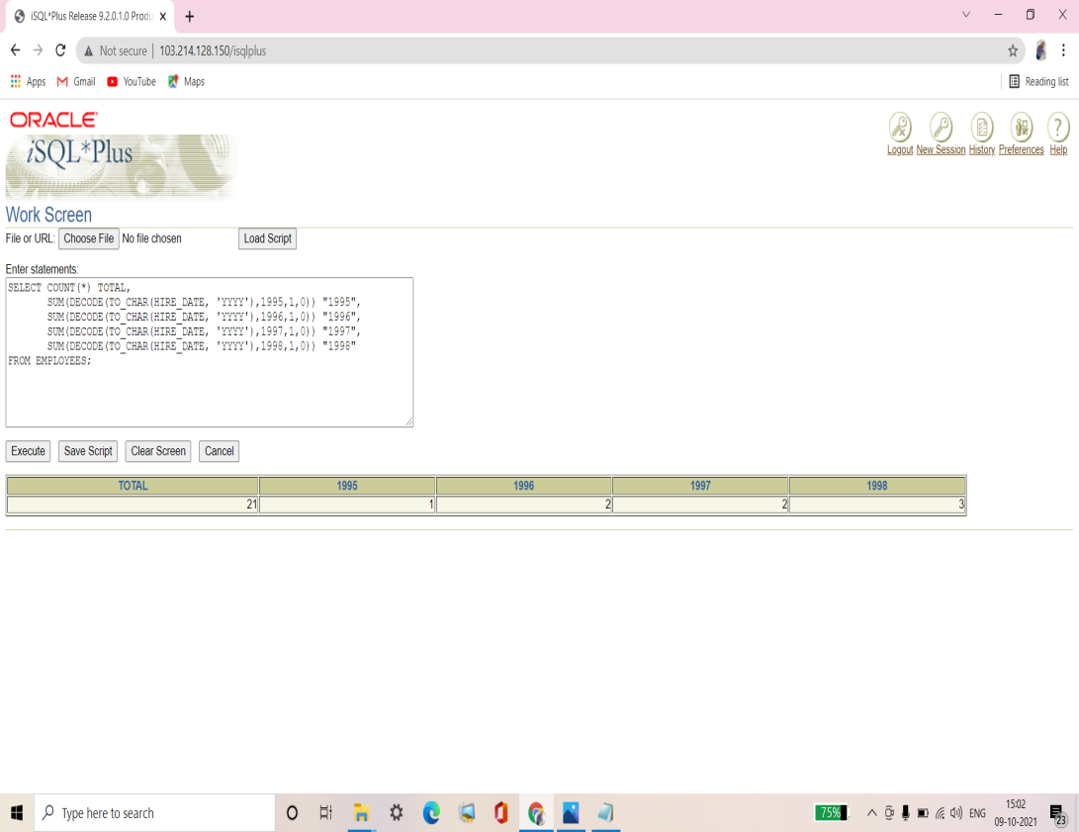

**Q12. Create a matrix query to display the job, the salary for that job based on department number, and the total salary for that job, for departments 20, 50, 80, and 90, giving each column an appropriate heading.**

|  |  |  |  |  |  |
| --- | --- | --- | --- | --- | --- |
| **Job** | **Dept 20** | **Dept 50** | **Dept 80** | **Dept 90** | **Total** |
| **AC_ACCOUNT** |  |  |  |  | **8300** |
| **AC_MGR** |  |  |  |  | **12000** |
| **AD_ASST** |  |  |  |  | **4400** |
| **AD_PRES** |  |  |  | **24000** | **24000** |
| **AD_VP** |  |  |  | **34000** | **34000** |
| **IT_PROG** |  |  |  |  | **19200** |
| **MK_MAN** | **13000** |  |  |  | **13000** |
| **MK_REP** | **6000** |  |  |  | **6000** |
| **SA_MAN** |  |  | **10500** |  | **10500** |
| **SA_REP** |  |  | **19600** |  | **26600** |
| **ST_CLERK** |  | **11700** |  |  | **11700** |
| **ST_MAN** |  | **5800** |  |  | **5800** |

**12 rows selected.**

Ans12.

SELECT JOB_ID "Job",

SUM(DECODE(DEPARTMENT_ID, 20, SALARY)) "Dept 20",

SUM(DECODE(DEPARTMENT_ID, 50, SALARY)) "Dept 50",

SUM(DECODE(DEPARTMENT_ID, 80, SALARY)) "Dept 80",

SUM(DECODE(DEPARTMENT_ID, 90, SALARY)) "Dept 90",

SUM(SALARY) "Total"

FROM EMPLOYEES

GROUP BY JOB_ID;

**Verification table –**

